**Week 2 – Notes**

**Logistic Regression as a Neural Network**

**Binary Classification**

The notation used throughout the course:

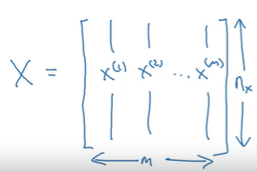 - features: one example per column (m columns) nx features (rows)

- targets: one target per column

**Logistic Regression**

**Logistic Regression Cost Function**

We denote

We cannot define the loss function as below because it isn’t convex

We define it as

The cost function is the average of all loss functions for each pair of y and y hat

**Gradient Descent**



We want to minimize J(w, b) – the cost function

The derivative represents the slope of the function in a point

With d we denote derivatives and with sigma we denote partial derivatives

This algorithm implies moving towards the minimum values of the function by repeatedly subtracting from each parameter the value given by alpha (learning rate) * the derivative of the function with respect to that parameter

**Derivatives**

Computes what’s the ratio between the change in the value of the function and the change of the variable, if we increase the variable just by a little (represents the height / width of the triangle that we draw with the hypotenuse as being the tangent)

**More Derivative Examples**

In machine learning the log always denotes the ln

**Computation graph**

Forward pass -> compute the outputs of the network

Backward pass -> Compute the gradients / derivatives

**Computing derivatives**

In this course, dvar is the notation of the derivative of the cost function with respect to the variables

To compute the derivative of J with respect to a, we use the chain rule:

To compute derivates we can use the defined formula, or to use the definition, but in which we consider x0 to be a small value, such as 0.001

**Logistic Regression Gradient Descent**

We have to update w1, w2 and b; for example w1 := w1 – alpha * dw1

**Gradient Descent on m Examples**

The superscript notation denotes the indices / number of the data example

We initialize J, dw1, dw2 and db with 0 and we compute them by adding the value computed in relation with each training example; after that we divide each variable with the number of examples

One iteration of the gradient descent means that we update w1, w2 and b:

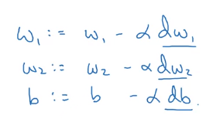

Because we want to avoid having many for loops, we’ll use the vectorized implementation

**Python and Vectorization**

**Vectorization**

Just by multiplying vectors / matrices without using for loops we can speed up the code by hundred of times

For example we can use np.dot(vec1, vec2) to multiply 2 vectors

Vectorized implementation benefit because of the SIMD instructions that are implemented on the CPU and GPU

**More Vectorization Examples**

Even the computation of the e^ of each element of a vector can be vectorized with np.exp(vector)

To vectorize the logistic regression, we would use dw as a vector instead of using dw1, dw2 and so on

**Vectorizing Logistic Regression**

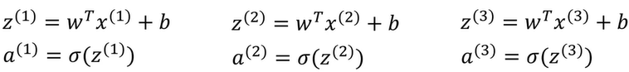

To compute z1, z2 etc we can use a vectorized implementation

, when you add a number to a vector, that number is added to each value from the vector; this operation is called broadcasting

**Vectorizing Logistic Regression's Gradient Output**

The gradient descent algorithm can be vectorized, so that for one iteration we won’t use any for loop

  

**Broadcasting in Python**

If you have a matrix (3, 4) and divide it by an array (1, 4), that array will be duplicated 3 times and then the division is done element-wise

The general rule:

(m, n) + - * / (1, n) => then the (1, n) is duplicated and transformed into a (m, n)

(m, n) + - * / (m, 1) =? Then the (m, 1) is duplicated and transformed into a (m, n)

Then, all the operations are done element-wise

**A Note on Python/Numpy Vectors**

np.array([1, 2]) + np.array([[1], [2]]) -> array([[2, 3], [3, 4]]), which is very strange

The transpose of a rank 1 array is the same array; a rank 1 array has the shape (n,) not (n, 1)

np.random.randn(5) -> (5,) but np.random.randn(5 ,1) -> (5, 1)

You can test the shape in the code by using assert(a.shape == (5, 1))

Do not use rank 1 arrays

**Explanation of Logistic Regression Cost Function (Optional)**

These 2 can be combined in a single formula:

Maximizing p(y|x) is the same as maximizing log p(y|x), considering that log is a strictly monotonic functionA picture containing text, handwriting, font, calligraphy

If you consider that the training examples are independent and identically distributed (i.i.d.), then you can

Maximum likelihood estimation = find the parameters of a probability distribution function that maximize the likelihood of the observed data

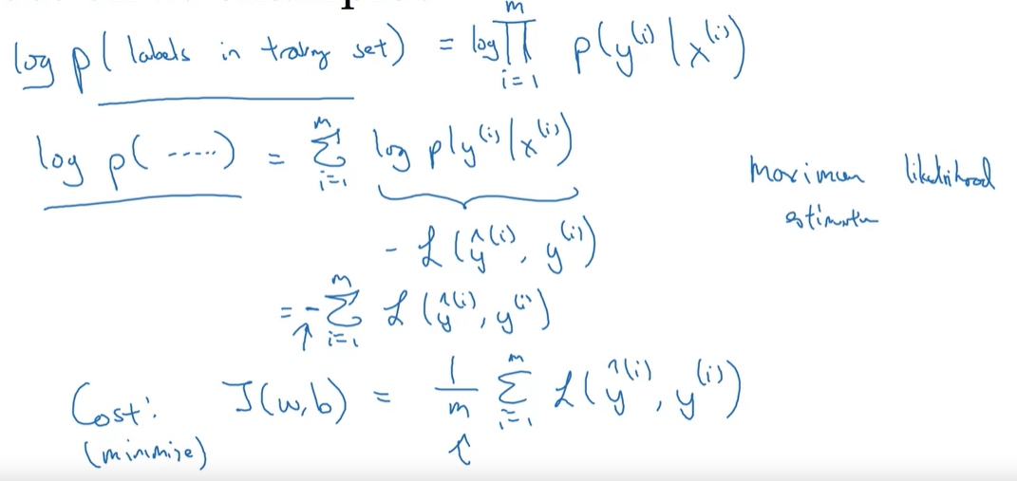

The 1 / m is just a scaling factor, for convenience

**Quiz**

Shape (1, 3) * shape (3, 3) => shape (3, 3) -> broadcasting is used

Only if we use np.dot(shape (1, 3), shape (3, 3)) we get shape (1, 3) -> broadcasting is not used

np.array * np.array is an element-wise multiplication

**Assignment: Python Basics with Numpy**

Np.exp is preferred, not math.exp because the first one can be used with arrays

We normalize a matrix by dividing it by its norm and we do this division for each row

np.dot – dot product -> for 1-D arrays and for 2-D arrays is like matmul

np.outer – outer product

np.multiply – element-wise multiplication -> for 3-D arrays of higher behaves differently

**Assignment: Logistic Regression with a Neural Network Mindset**

Data is stored in an HDF5 format (Hierarchical Data Format) and can be read with h5py

Usually the data is reshaped, so that we have one example per column

Images are preprocessed by dividing their values with the max value (255)

Pick the learning rate based on the curve of the loss function, not the measured metric